Hoodie   
Grösse XS – 5XL  
CHF 39.95

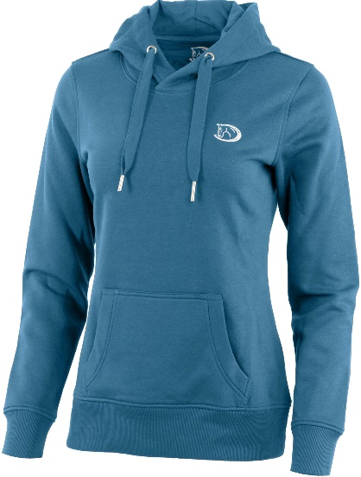

Sweatjacke  
Grösse XS – 5XL  
CHF 49.95

